Article ID: 7212
Article Name: How do I clean my nozzles wheels and brush.
Topic Location: Floorcare, bag/bagless/central cleaners,cleaning and maintenance.
Meta-data: cleaning, rinse, cleanse, depurate.
Related Articles:
Related Questions:
PNC
DIY
Safety
Link
Email
Book Engineer
Multimedia
Brand
Article Content:
To clean a passive nozzle follow these steps:
- Vacuum the plush surface and the underside of the nozzle.
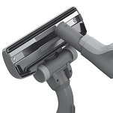
- Loosen the wheels with a small screwdriver and clean them. 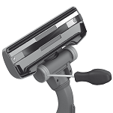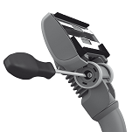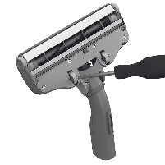

To clean a active nozzle with motor brush follow this steps:
- Open the brush roll cover by pushing latches.
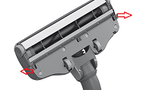
- Pull out the brush roll and remove entangled threads with a scissor, vacumm the brush roll and the brush roll compartment.
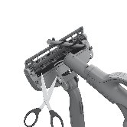
- Use a small screw driver to remove the small wheels, most front wheels are removable when brush roll cover is opend. Clean wheels and axles.
This is more or less standard on most nozzles. If you nozzle doesn’t apply to this instruction, please refer to you instruction manual searchable in the link below.

[Link to instruction manual download]

